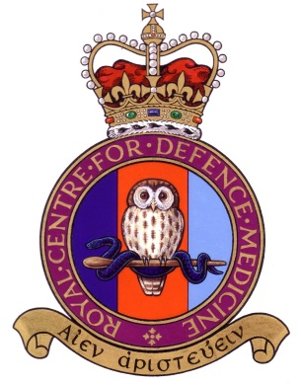 |  |  |  |  | 
Sgt J W Rowland

Royal Centre for Defence Medicine (Operational)
Joint Hospital Group
Oxford University Hospital Trust,
Military Office, Room 3503, Level 3 JR2
The John Radcliffe Hospital,
Headington, Oxford,
OX3 9DU

Telephone: 01865226861
MODNET: joshua.rowland108@mod.gov.uk

See Distribution. |  |  | Reference:
 |  |  | Date:

PMRAFNS THANKSGIVING SERVICE 2022

On 15 Jun 22, PMRAFNS from Royal Centre of Defence Medicine (Oxford) hosted the PMRAFNS Thanksgiving Service 2022, for serving and veteran persons.
Attendance of 50 people was made up of serving PMRAFNS from Royal Centre of Defence Medicine (Oxford), Royal Centre of Defence Medicine (Birmingham), and notable guests from HQ Air Command; including WO Kay Ward, WO Defence Nursing Service (RAF) and Gp Capt Micheal Priestley, Commander Medical Services (RAF).
Alongside serving personnel, veterans from PMRAFNS Association attended including PMRAFNS Association Chairman, WO (Rtd) Bob Sanderson.

The event Project Team, led by Sgt Joshua Rowland, organised a day to remember. Affording the opportunity for guests to reflect on their experiences whilst serving in the PMRAFNS, during a respectful church service, delivered by Rvd (Sqn Ldr) Adrian Klos.
Interspersed between inspiring readings from Gp Capt Priestley and Flt Lt Pierce, and hymns, personal reflections were presented to the group by WO (Rtd) Sanderson, on his time serving and Flt Lt Adam Whitford, who gave an overview of recent Operations he had been part of. All of which was extremely well received by the audience and highlighted just how important PMRAFNS have been to effective Operations, whether that be during conflict or providing humanitarian aid, or simply day to day assistance to the NHS during more peaceful times.

Thanks to PMRAFNS Trust and PMRAFNS Association, who equally supported the event financially, once the Thanksgiving Service at the church had concluded and everyone had changed into more comfortable attire for the scorching hot day, the merriment continued with a buffet luncheon reception at The Shepherd’s Hut; a lovely country pub, situated by the watercress gardens and river in Ewelme. Where a huge spread of continental finger foods was on offer, for all to enjoy…which they certainly did!
Stories, memories and experiences were shared between people, in this pleasant venue, and allowed guests to chat with friends old and new.
A delightful day of reflection and camaraderie, iced with plenty of delicious food and drink made this occasion a must attend event and we look forward to next years!

